**Q1: Can you create a simple HTML navigation bar to navigate to a list of items with basic styling using CSS?**

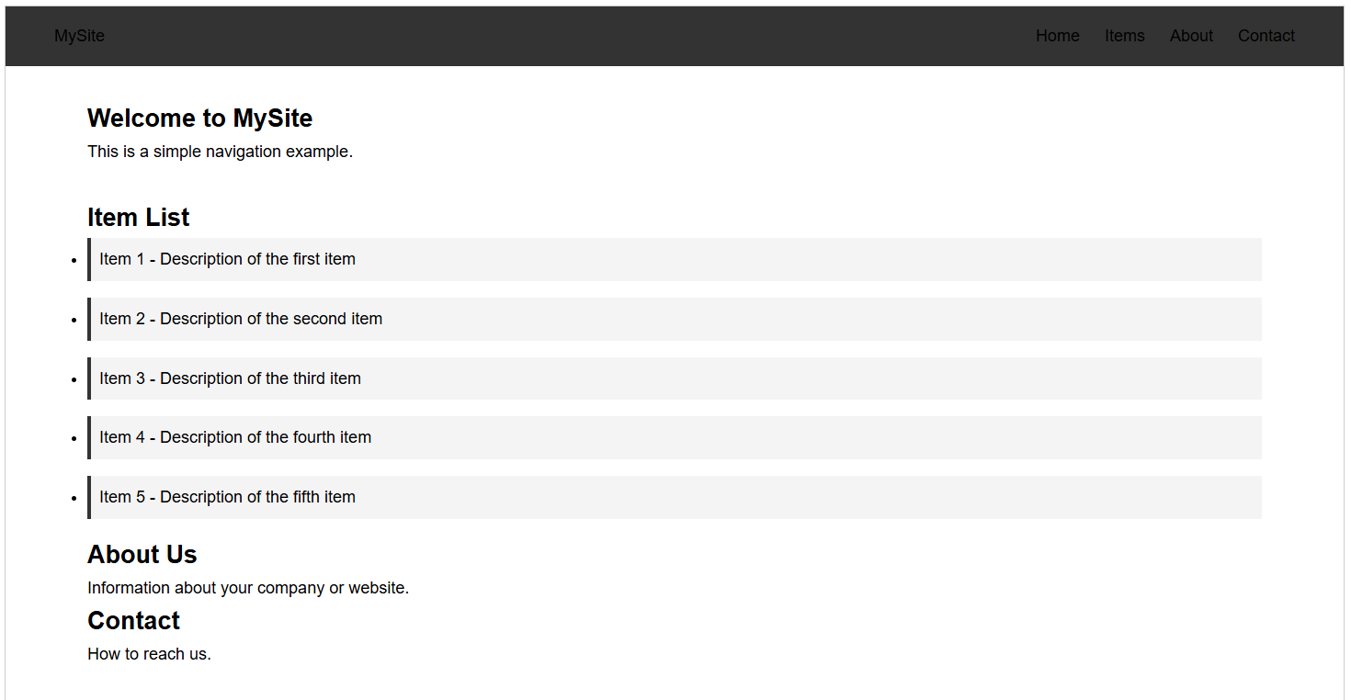

<!DOCTYPE html>

<html lang="en">

<head>

<meta charset="UTF-8">

<meta name="viewport" content="width=device-width, initial-scale=1.0">

<title>Navigation Bar Example</title>

<style>

/* Reset some default styles */

* {

margin: 0;

padding: 0;

box-sizing: border-box;

}

body {

font-family: Arial, sans-serif;

line-height: 1.6;

}

/* Navigation bar styles */

nav {

background-color: #333;

padding: 1rem 2rem;

}

.nav-container {

max-width: 1200px;

margin: 0 auto;

display: flex;

justify-content: space-between;

align-items: center;

}

.logo {

color: white;

text-decoration: none;

font-size: 1.5rem;

font-weight: bold;

}

.nav-links {

display: flex;

list-style: none;

}

.nav-links li {

margin-left: 1.5rem;

}

.nav-links a {

color: white;

text-decoration: none;

padding: 0.5rem 1rem;

border-radius: 4px;

transition: background-color 0.3s;

}

.nav-links a:hover {

background-color: #555;

}

/* Content section styles */

.content {

max-width: 1200px;

margin: 2rem auto;

padding: 0 2rem;

}

.item-list {

margin-top: 2rem;

}

.item-list li {

margin-bottom: 1rem;

padding: 0.5rem;

background-color: #f4f4f4;

border-left: 4px solid #333;

}

</style>

</head>

<body>

<nav>

<div class="nav-container">

<a href="#" class="logo">MySite</a>

<ul class="nav-links">

<li><a href="#home">Home</a></li>

<li><a href="#items">Items</a></li>

<li><a href="#about">About</a></li>

<li><a href="#contact">Contact</a></li>

</ul>

</div>

</nav>

<div class="content">

<section id="home">

<h1>Welcome to MySite</h1>

<p>This is a simple navigation example.</p>

</section>

<section id="items" class="item-list">

<h2>Item List</h2>

<ul>

<li>Item 1 - Description of the first item</li>

<li>Item 2 - Description of the second item</li>

<li>Item 3 - Description of the third item</li>

<li>Item 4 - Description of the fourth item</li>

<li>Item 5 - Description of the fifth item</li>

</ul>

</section>

<section id="about">

<h2>About Us</h2>

<p>Information about your company or website.</p>

</section>

<section id="contact">

<h2>Contact</h2>

<p>How to reach us.</p>

</section>

</div>

</body>

</html>

**Q2: Build an HTML navigation bar styled with CSS and include a JavaScript function to show or hide the options based on a user’s action (e.g., clicking a button).**

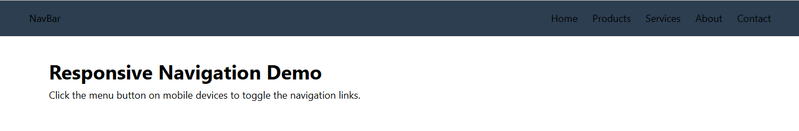

<!DOCTYPE html>

<html lang="en">

<head>

<meta charset="UTF-8">

<meta name="viewport" content="width=device-width, initial-scale=1.0">

<title>Toggle Navigation Bar</title>

<style>

/* Reset and base styles */

* {

margin: 0;

padding: 0;

box-sizing: border-box;

}

body {

font-family: 'Segoe UI', Tahoma, Geneva, Verdana, sans-serif;

line-height: 1.6;

}

/* Navigation bar styles */

nav {

background-color: #2c3e50;

padding: 1rem 2rem;

position: relative;

}

.nav-container {

max-width: 1200px;

margin: 0 auto;

display: flex;

justify-content: space-between;

align-items: center;

}

.logo {

color: white;

text-decoration: none;

font-size: 1.5rem;

font-weight: bold;

}

.nav-links {

display: flex;

list-style: none;

transition: all 0.3s ease;

}

.nav-links li {

margin-left: 1.5rem;

}

.nav-links a {

color: white;

text-decoration: none;

padding: 0.5rem 1rem;

border-radius: 4px;

transition: background-color 0.3s;

display: block;

}

.nav-links a:hover {

background-color: #34495e;

}

/* Mobile menu button */

.menu-btn {

display: none;

background: none;

border: none;

color: white;

font-size: 1.5rem;

cursor: pointer;

}

/* Content styles */

.content {

max-width: 1200px;

margin: 2rem auto;

padding: 0 2rem;

}

/* Responsive styles */

@media (max-width: 768px) {

.menu-btn {

display: block;

}

.nav-links {

position: absolute;

top: 100%;

left: 0;

width: 100%;

background-color: #2c3e50;

flex-direction: column;

padding: 1rem 2rem;

clip-path: polygon(0 0, 100% 0, 100% 0, 0 0);

}

.nav-links.active {

clip-path: polygon(0 0, 100% 0, 100% 100%, 0 100%);

}

.nav-links li {

margin: 0.5rem 0;

}

}

</style>

</head>

<body>

<nav>

<div class="nav-container">

<a href="#" class="logo">NavBar</a>

<button class="menu-btn" id="menuBtn">☰</button>

<ul class="nav-links" id="navLinks">

<li><a href="#home">Home</a></li>

<li><a href="#products">Products</a></li>

<li><a href="#services">Services</a></li>

<li><a href="#about">About</a></li>

<li><a href="#contact">Contact</a></li>

</ul>

</div>

</nav>

<div class="content">

<h1 id="home">Responsive Navigation Demo</h1>

<p>Click the menu button on mobile devices to toggle the navigation links.</p>

</div>

<script>

document.addEventListener('DOMContentLoaded', function() {

const menuBtn = document.getElementById('menuBtn');

const navLinks = document.getElementById('navLinks');

// Toggle menu visibility

menuBtn.addEventListener('click', function() {

navLinks.classList.toggle('active');

// Change button icon based on menu state

if (navLinks.classList.contains('active')) {

menuBtn.textContent = '✕';

} else {

menuBtn.textContent = '☰';

}

});

// Close menu when a link is clicked (for mobile)

navLinks.querySelectorAll('a').forEach(link => {

link.addEventListener('click', function() {

if (window.innerWidth <= 768) {

navLinks.classList.remove('active');

menuBtn.textContent = '☰';

}

});

});

// Close menu when clicking outside (optional)

document.addEventListener('click', function(event) {

if (!event.target.closest('nav') && window.innerWidth <= 768) {

navLinks.classList.remove('active');

menuBtn.textContent = '☰';

}

});

});

</script>

</body>

</html>

**Q3: Create a responsive HTML, CSS, and JavaScript interface that displays a navigation bar where certain options are visible only to a user with permission.**

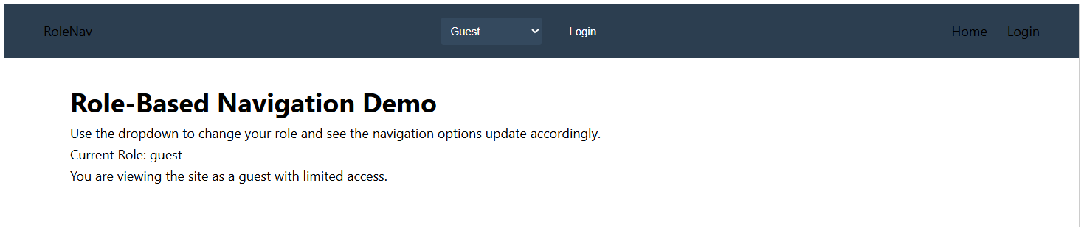

<!DOCTYPE html>

<html lang="en">

<head>

<meta charset="UTF-8">

<meta name="viewport" content="width=device-width, initial-scale=1.0">

<title>Role-Based Navigation</title>

<style>

/* Reset and base styles */

* {

margin: 0;

padding: 0;

box-sizing: border-box;

}

body {

font-family: 'Segoe UI', Tahoma, Geneva, Verdana, sans-serif;

line-height: 1.6;

padding-top: 60px;

}

/* Navigation bar styles */

nav {

background-color: #2c3e50;

padding: 1rem 2rem;

position: fixed;

width: 100%;

top: 0;

z-index: 1000;

}

.nav-container {

max-width: 1200px;

margin: 0 auto;

display: flex;

justify-content: space-between;

align-items: center;

}

.logo {

color: white;

text-decoration: none;

font-size: 1.5rem;

font-weight: bold;

}

.nav-links {

display: flex;

list-style: none;

transition: all 0.3s ease;

}

.nav-links li {

margin-left: 1.5rem;

position: relative;

}

.nav-links a {

color: white;

text-decoration: none;

padding: 0.5rem 1rem;

border-radius: 4px;

transition: background-color 0.3s;

display: block;

}

.nav-links a:hover {

background-color: #34495e;

}

.admin-badge {

position: absolute;

top: -5px;

right: -5px;

background-color: #e74c3c;

color: white;

border-radius: 50%;

width: 16px;

height: 16px;

font-size: 10px;

display: flex;

align-items: center;

justify-content: center;

}

/* Mobile menu button */

.menu-btn {

display: none;

background: none;

border: none;

color: white;

font-size: 1.5rem;

cursor: pointer;

}

/* User controls */

.user-controls {

display: flex;

align-items: center;

gap: 1rem;

margin-left: 2rem;

}

.user-btn {

background: none;

border: none;

color: white;

cursor: pointer;

padding: 0.5rem 1rem;

border-radius: 4px;

}

.user-btn:hover {

background-color: #34495e;

}

/* Role selector dropdown */

.role-selector {

padding: 0.5rem;

border-radius: 4px;

border: none;

background-color: #34495e;

color: white;

}

/* Content styles */

.content {

max-width: 1200px;

margin: 0 auto;

padding: 2rem;

}

/* Responsive styles */

@media (max-width: 992px) {

.nav-links {

position: absolute;

top: 100%;

left: 0;

width: 100%;

background-color: #2c3e50;

flex-direction: column;

padding: 1rem 2rem;

clip-path: polygon(0 0, 100% 0, 100% 0, 0 0);

}

.nav-links.active {

clip-path: polygon(0 0, 100% 0, 100% 100%, 0 100%);

}

.nav-links li {

margin: 0.5rem 0;

}

.menu-btn {

display: block;

}

.user-controls {

margin-left: auto;

margin-right: 1rem;

}

}

</style>

</head>

<body>

<nav>

<div class="nav-container">

<a href="#" class="logo">RoleNav</a>

<div class="user-controls">

<select id="roleSelector" class="role-selector">

<option value="guest">Guest</option>

<option value="user">Standard User</option>

<option value="admin">Administrator</option>

<option value="superadmin">Super Admin</option>

</select>

<button class="user-btn" id="loginBtn">Login</button>

</div>

<button class="menu-btn" id="menuBtn">☰</button>

<ul class="nav-links" id="navLinks">

<li><a href="#home">Home</a></li>

<li class="user-only"><a href="#profile">Profile</a></li>

<li class="user-only"><a href="#messages">Messages</a></li>

<li class="admin-only"><a href="#dashboard">

Admin Dashboard

<span class="admin-badge">A</span>

</a></li>

<li class="superadmin-only"><a href="#system">

System Settings

<span class="admin-badge">SA</span>

</a></li>

<li class="user-only"><a href="#logout">Logout</a></li>

<li class="guest-only"><a href="#login">Login</a></li>

</ul>

</div>

</nav>

<div class="content">

<h1 id="home">Role-Based Navigation Demo</h1>

<p>Use the dropdown to change your role and see the navigation options update accordingly.</p>

<div id="roleInfo" style="margin-top: 2rem; padding: 1rem; background: #f5f5f5; border-radius: 4px;">

<h3>Current Role: <span id="currentRole">guest</span></h3>

<p id="roleDescription">You are viewing the site as a guest with limited access.</p>

</div>

</div>

<script>

document.addEventListener('DOMContentLoaded', function() {

const menuBtn = document.getElementById('menuBtn');

const navLinks = document.getElementById('navLinks');

const roleSelector = document.getElementById('roleSelector');

const loginBtn = document.getElementById('loginBtn');

const currentRoleDisplay = document.getElementById('currentRole');

const roleDescription = document.getElementById('roleDescription');

// Role descriptions

const roleDescriptions = {

guest: "You are viewing the site as a guest with limited access.",

user: "You are logged in as a standard user with basic privileges.",

admin: "You have administrator access with additional controls.",

superadmin: "You have full system access with all privileges."

};

// Initialize the navigation based on default role

updateNavigation('guest');

// Toggle menu visibility

menuBtn.addEventListener('click', function() {

navLinks.classList.toggle('active');

// Change button icon based on menu state

if (navLinks.classList.contains('active')) {

menuBtn.textContent = '✕';

} else {

menuBtn.textContent = '☰';

}

});

// Role selector change handler

roleSelector.addEventListener('change', function() {

const selectedRole = this.value;

updateNavigation(selectedRole);

// Update login button text

loginBtn.textContent = selectedRole === 'guest' ? 'Login' : 'Logout';

});

// Login/logout button handler

loginBtn.addEventListener('click', function() {

if (roleSelector.value === 'guest') {

// Default to user role when logging in

roleSelector.value = 'user';

} else {

// Return to guest when logging out

roleSelector.value = 'guest';

}

// Trigger the change event

roleSelector.dispatchEvent(new Event('change'));

});

// Close menu when a link is clicked (for mobile)

navLinks.querySelectorAll('a').forEach(link => {

link.addEventListener('click', function() {

if (window.innerWidth <= 992) {

navLinks.classList.remove('active');

menuBtn.textContent = '☰';

}

});

});

// Function to update navigation based on role

function updateNavigation(role) {

// Hide all role-specific elements first

document.querySelectorAll('.user-only, .admin-only, .superadmin-only, .guest-only')

.forEach(el => el.style.display = 'none');

// Show elements based on role

switch(role) {

case 'superadmin':

document.querySelectorAll('.superadmin-only, .admin-only, .user-only')

.forEach(el => el.style.display = 'block');

break;

case 'admin':

document.querySelectorAll('.admin-only, .user-only')

.forEach(el => el.style.display = 'block');

break;

case 'user':

document.querySelectorAll('.user-only')

.forEach(el => el.style.display = 'block');

break;

default: // guest

document.querySelectorAll('.guest-only')

.forEach(el => el.style.display = 'block');

}

// Update role info display

currentRoleDisplay.textContent = role;

roleDescription.textContent = roleDescriptions[role];

}

// Close menu when clicking outside (optional)

document.addEventListener('click', function(event) {

if (!event.target.closest('nav') && window.innerWidth <= 992) {

navLinks.classList.remove('active');

menuBtn.textContent = '☰';

}

});

});

</script>

</body>

</html>